Checking Your Grades

You should be able to view grades for all of your classes in Blackboard. If you have any questions about grades or how to view a returned assignment, ask your instructor.

To view your grades in Blackboard, you have two options.
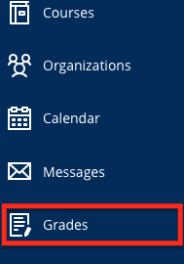
- From the base navigation menu, click on Grades.
  - This method will display your total grade and recent grades for all of your courses, so it is more like a quick snapshot rather than a comprehensive view.
  - Here, your grades appear color coded with higher grades in green, mid-range grades in yellow, and low grades in red.
  - To view more grades for a specific course, click on the course title, any of the graded assignment titles under that course title, or the View all work link at the bottom of the Recent Grades list.

- From your course menu, click on My Grades.
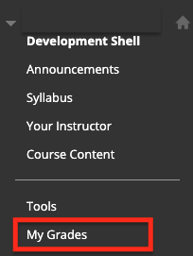
- This method displays your total grade and all individual grades for only the course you are currently viewing.
- This is the preferred method since you can see all of your course grades and have a comprehensive view of where you stand.
- This view also allows you to confirm submitted items, see any rubrics provided, and view any comments or feedback from your instructor.
- Click on an assignment title to review your submission, see instructor annotations made directly on your submission, and view rubrics and feedback along with your score—all in one place.
- You can change which items appear in the My Grades view by clicking on the following headings that appear at the top of the screen.
  - All: Shows your total grade columns and every item currently in the gradebook including graded, upcoming, and submitted items.
  - Graded: Shows only the items your instructor has graded so far.
  - Upcoming: Shows only the items you are working on or that are coming up but have not yet been submitted or graded.
  - Submitted: Shows only items you have submitted that have not yet been graded.

Please see the following page to learn what the My Grades icons mean as well as how to navigate to the different views listed above.
